Ramsey Volunteer Fire Department
1983 Mack Tower Ladder 441
Commemorative Challenge Coin

After 35 years of service to the Boro of Ramsey , our Mack Tower Ladder 441 has been retired. To commemorate her - the Ramsey Volunteer Fire Department has commissioned a limited number of commemorative challenge coins. The coin features a 3D front with an angle view of 441 and the back of the coin is the rear of 441 featuring a mural of the firemen’s memorial and bucket.
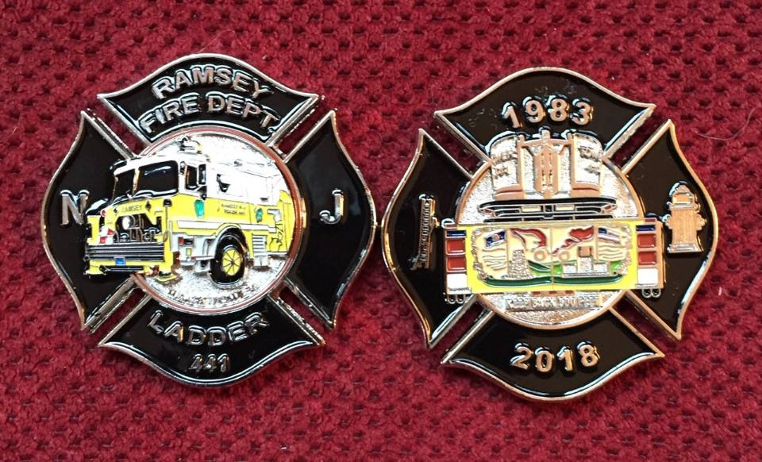
The coin is $10 and is available any Monday Night after 7 pm at the Ramsey Fire Department Headquarters – 25 S. Island Ave, Ramsey NJ or contact any Ramsey Firefighter.

